
Pre-visit Activity
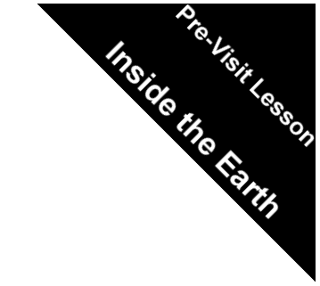
Duration: 30 minutes

Objectives: After completing the lesson, students should be able to:
1. Name the different layers of the Earth
2. Describe in basic terms the structure of the Earth.

Key Concept: Structure of the Earth. Multiple intelligence approaches: kinesthetic, spatial/visual, mathematical/logical.

Content Standard: Earth and Space Science: Properties of Earth materials.

Materials:

Slips of paper (colored or numbered – see chart following)
Easel Paper or chalkboard
Drawing of Earth wedge
Giant chalk

Procedure:

In this activity students will construct the structure of the Earth using their bodies. Begin by showing the students an enlarged version of the diagram of a slice of the Earth below. Draw the diagram on a piece of easel paper, chalk board or school playground. Discuss the structure of the Earth. Explain that the Earth has three main parts: crust, mantle and core. This can also be illustrated with an apple by cutting out a wedge. Explain that the three main layers of the Earth are also broken down into sublayers. Show where these are located on the diagram. Using the background information included with this guide, discuss the layers and sublayers of the Earth.

Strips of paper to represent layers of the Earth. The quantity and ratio may be dependent upon your class size.
Purple= Inner core qty 1 | Inner core 1216 km; 1950 mi
Red = Outer core qty 3 | Outer core – 2270 km; 3632 mi
Orange = Mantle qty 6 | Mantle – 2900 km; 4640 mi (asthenosphere and deep mantle)
Brown = Crust qty 12 | Crust – 5-70 km; 10 – 110 mi (top soil, crust and lithosphere)
Mountain – Gray
Ocean - Blue

B-9
Take the students to a large open area and explain that they are going to work together to build the structure of the Earth. Place the strips of paper (that are either color-coded or marked with one of the layers of the Earth) in a bowl or hat. Have the students randomly pick a part to play. Explain to the students what each part does. Allow the students to practice movements and sounds before constructing the layers of the Earth.

Constructing the layers:

If possible draw an outline of the “Earth wedge” using large chalk. Draw the boundaries of the layers of the Earth.

Core: the person(s) representing the Earth’s core will act solid and hot. Have them choose a stance that flexes their muscles and puff out the cheeks as if bursting with energy. The person representing the core will stand at the center of the Earth or bottom of the wedge. This represents that the core is very dense, solid and extremely hot. Remind them that the core has a thickness of 1950 miles

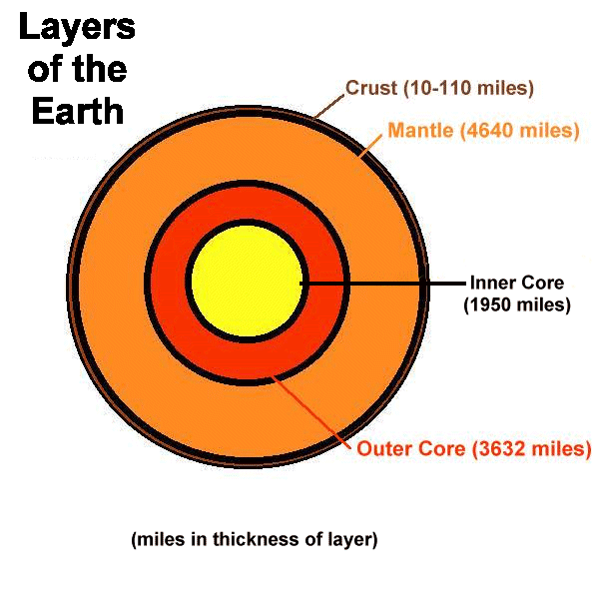
Outer core: The outer core persons are to represent a liquid state which is extremely hot. Have the students face the inner core, and have them move clockwise around the inner core while waving their hands around or up and down. Be sure to tell the students that this represents that the outer core moves or circulates because it is liquid. Remind the students that the outer core is very thick, approximately 3,600 miles thick.

Mantle: Have the students who are the mantle pair up and position themselves around the inner core. They will hold hands and slowly turn around in a circular motion. Have them chant the words “hot rock, hot rock, hot rock.” Have them positioned sporadically around the inner core but maintain position as a pair. Turn first clockwise and then counterclockwise each for 5 – 10 turns. This represents that the mantle is hot and moving. The mantle is believed to have many convection currents (illustrated in background information). These currents effect the crust by pulling crustal plates along the currents. They may be viewed as the engine that causes plate tectonic events. Remind the students that the mantle is very thick, approximately 4640 miles thick.
B-10

Crust: Have the students who play the crust form a circle around the rest of the group, facing outward. They can move slowly and creak. Have them chant, “moving pates, moving plates” to represent that the crust of the Earth is made up of about 12 major plates that float on top of the mantle. Have one or two students play as mountains and another as the oceans. The crust of the Earth is believed to be from 10 to 110 miles thick. The crust is thicker on the continents and thinner on the oceans’ floor.

Assessment: One of the major messages of this activity is that the crust is extremely thin compared to the mass of the Earth and the thickness of other layers. The energy trapped inside the Earth makes the material molten or liquid. The energy also creates forces of movement upon the earth. This movement is what creates new rock, such as in volcanoes or metamorphism of rock, and changes the landscape on Earth, such as in the birth of mountains. The very nature that Earth is a “warm planet” provides the basis of life on Earth’s surface.
B-11
Note: thicknesses of layers within the Earth vary between resources. Numbers used in this activity were taken from the following book. Tarbuck J. Edward and Lutgens K. Frederick, Earth: An Introduction to Physical Geography. Prentice Hall, 1999
